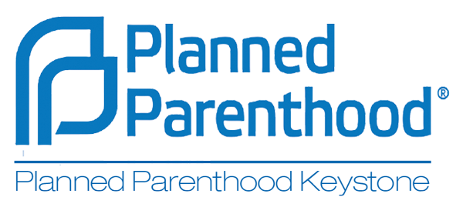
2015 HCAP Internship

Who We Are: Planned Parenthood Keystone’s mission is to provide and promote access to the essential health care services and comprehensive education people need to live healthy lives and build strong communities. The Harrisburg-based public affairs staff strives to educate our community, including elected officials about the importance of defending and increasing access to family planning services, abortion services, and sexuality education.
The Health Center Advocacy Program (HCAP) Inside health centers, volunteers and staff educate patients about the political world in which the services they are receiving exist. Outside the health centers, volunteers and staff disseminate information about our health services to the surrounding communities.
Requirements
- Commitment to reproductive health and rights for all Pennsylvanians and to Planned Parenthood’s mission
- Independent worker who is well organized and who can self-motivate.
- Maintain a regular, but flexible, schedule with hours that suit both the intern and office staff
- Commit to four hours a week out in the community and/or in a medical center
- Willingness to participate actively in all planned community or grassroots outreach, such as phone banking, door-to-door and crowd canvassing
- Outgoing team player, independent worker, who is well organized and who can self-motivate
- Desire to engage underrepresented populations and Planned Parenthood patients through community engagement and grassroots organizing tactics
- Must possess a basic understanding of Microsoft Office (especially Word and Excel) and Google Docs.
- Experience in marketing, sexual education and/or political advocacy a plus, but not required
Internship Description: Applicants must have a strong, demonstrated commitment to reproductive freedom and family planning services. Familiarity and proficiency with various programs is necessary. The successful candidate will be responsible for the following tasks and others assigned for the duration of the internship:
- Ensuring advocacy stations in health centers are equipped with appropriate material
- Educate health center visitors and staff about the advocacy work of Planned Parenthood Keystone including issues such as the PA Agenda for Women’s Health and the Affordable Care Act
- Sign up supporters of women’s health and enter the new supporters into the PP data system
- Register new voters
- Organize and participate in “Healthy Neighborhood” canvasses to drive patients to health centers
- Serve as a liaison between designated public affairs staff and health center staff
- Participate in bi-weekly or monthly calls to check in with statewide organizers.
- Complete office related tasks.
- Assist the office staff with day to day operations as appropriate.
Please note that this is an unpaid internship that requires at least 5 hours per week + training. This position may qualify for school credit. Please e-mail your resume as a Word Document or PDF to volunteer@planitpa.org with “HCAP Internship” in the subject line. Or contact our Grassroots Organizers at advocacy@planitpa.org directly with any questions.

